**Gen AI is an integrated feature in Pega. So first we need to navigate to the Case type and create a new case type from App Studio**

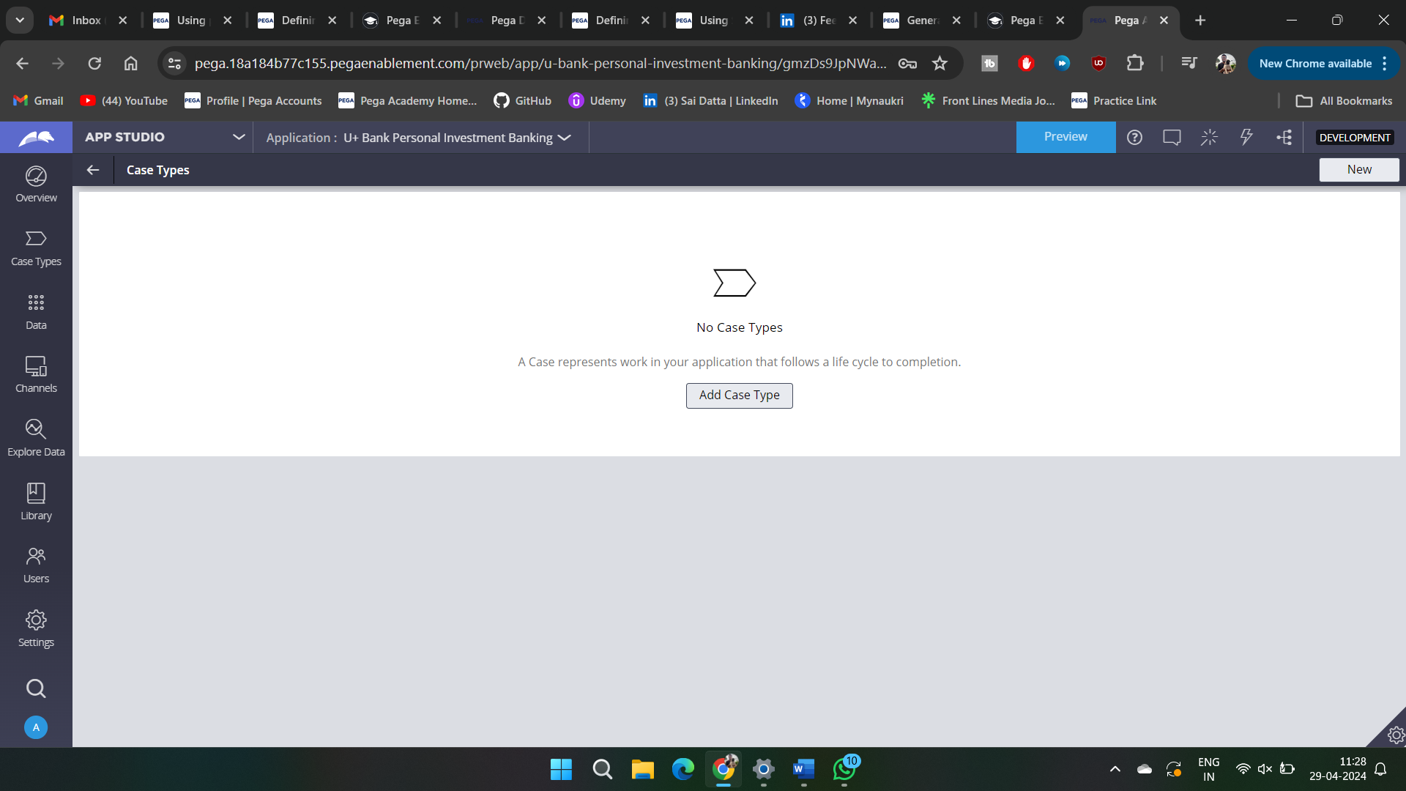

**Select 2nd option from the categories**

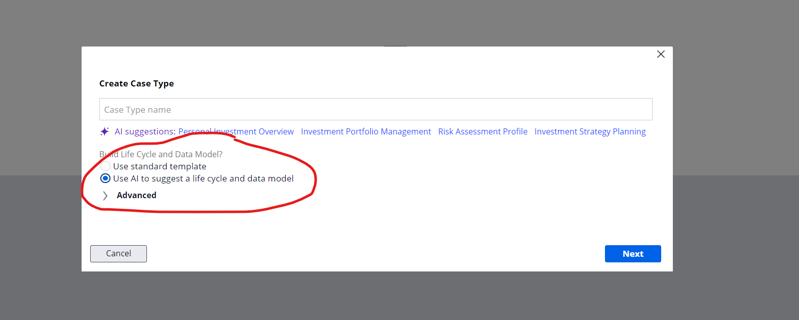

**And it will generate the stages and cycles which are suitable based on the domain**

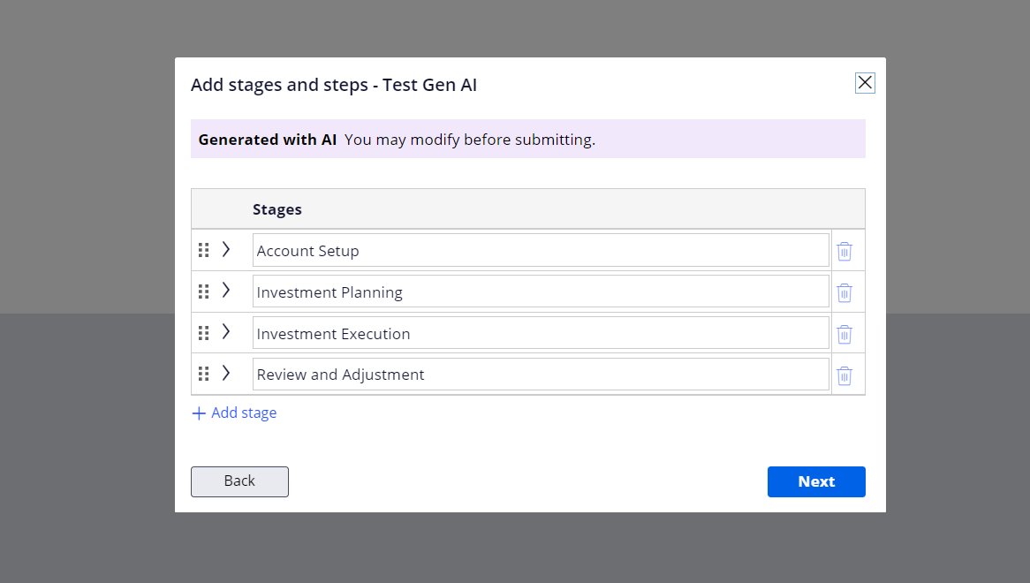

**Some fields and data model are pre fetched and also you can generate with AI**

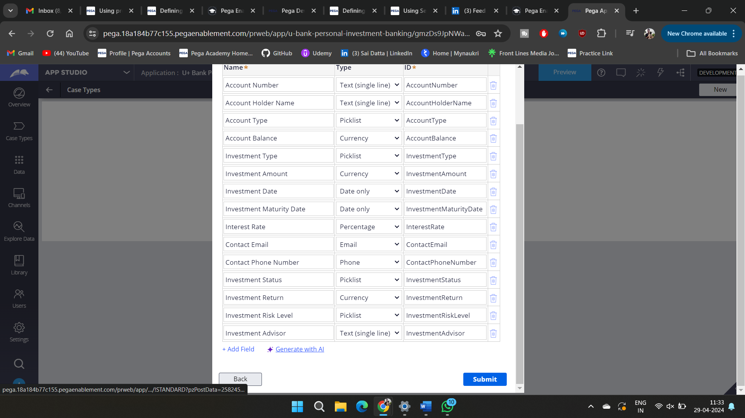

**We can also generate the Records with Gen AI**

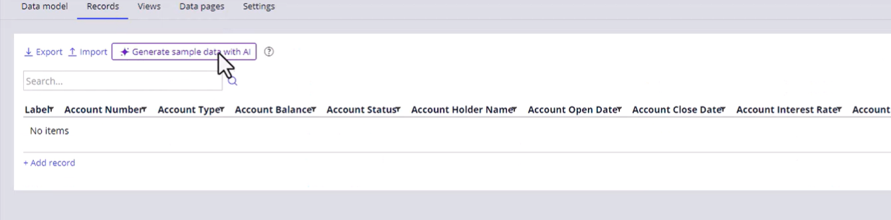

**How many records to fetch**

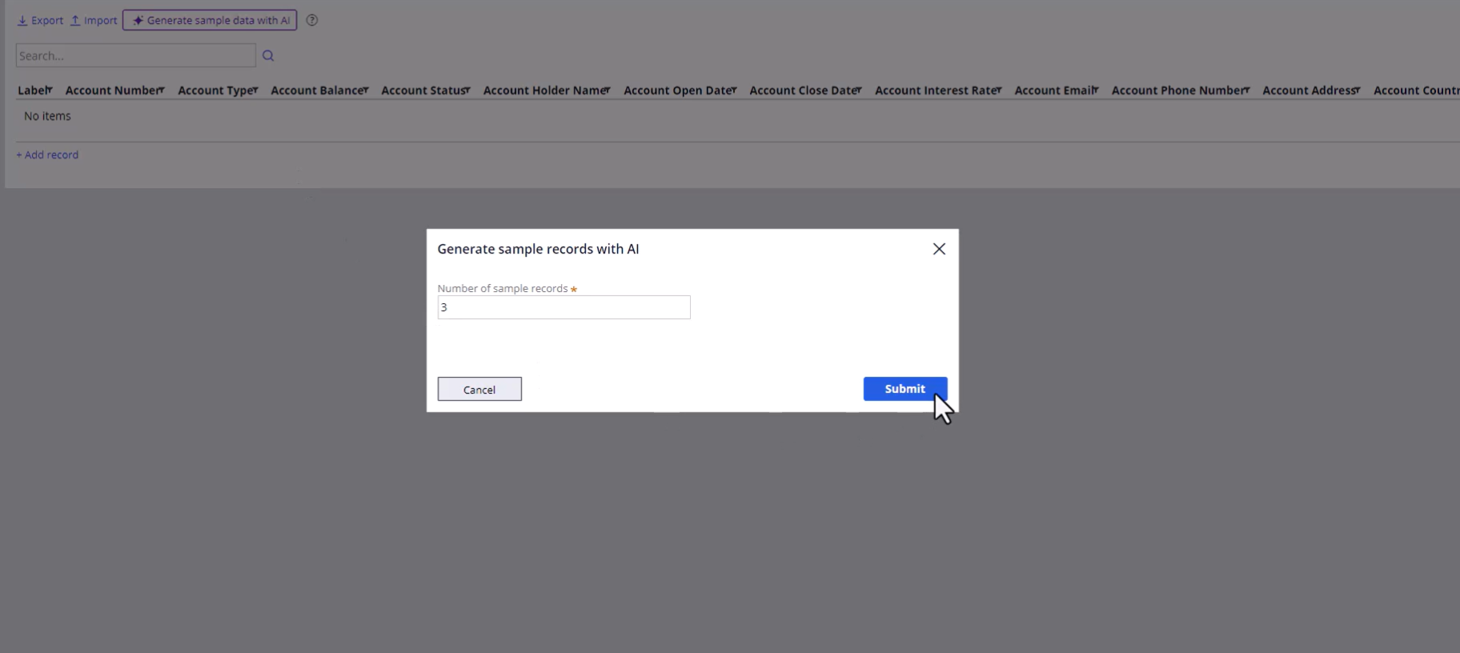

**We can also build user persona and help it with the Generated with AI and personas and descriptions.**

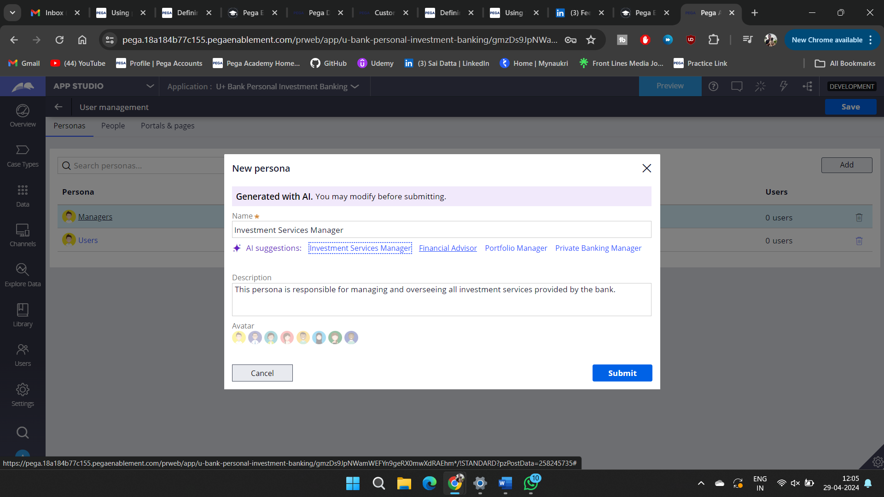

**Now we can do all the things from the Gen AI**

